Exercise 2.1: Getting Started with Django

**Learning Goals Reflections:**

1. **Comparing MVT with MVC:** Django’s Model-View-Template (MVT) architecture is similar to the Model-View-Controller (MVC) structure, but with one significant change: it focuses on templates rather than controllers. In MVT, the “View” is not responsible for handling data directly but rather serves up templates that present the data to the user. This separation makes Django unique in handling web content, giving it a leaner approach that simplifies the development workflow. MVC, on the other hand, tends to be more common outside Django and provides a controller for more direct handling of input logic.
2. **Django’s Benefits and Drawbacks:** Django is known for its robustness and ease of use for developers, with features like URL routing, authentication, and database ORM built-in. It speeds up the development process and ensures high security by default, which is beneficial for fast-paced development. However, Django has a few drawbacks, such as its large setup size and some constraints on flexibility due to its “Django way” of doing things, which may not be ideal for every project.

**Reflection Questions:**

1. **Choosing Between Vanilla Python and Django:** If I were a web developer making this decision, I’d weigh the trade-offs based on project scope and complexity. Using vanilla Python is simple and offers high flexibility, making it ideal for small projects or specific tasks where a heavy framework isn’t necessary. However, for larger projects requiring consistent handling of requests, data, and security, Django would be advantageous. Django’s structure saves time, enforces security, and has a vast library of built-in functions, which would make development smoother and faster compared to building similar functionality from scratch with vanilla Python.
2. **Significant Advantage of MVT Over MVC:** The standout advantage of MVT over MVC is its efficiency in rendering views, thanks to Django’s templating engine. In MVT, views are simple and concise, focusing on managing presentation templates rather than handling input and data processing, which is left to models. This distinction allows for a cleaner, more modular approach where views focus solely on displaying content, making Django especially user-friendly for web developers.
3. **Goals for this Django Achievement:**
   * **Goal 1:** Gain a solid grasp of Django’s core components and how they interconnect. I want to understand the internal workings of the MVT architecture to leverage Django’s full potential in web projects.
   * **Goal 2:** Build a fully functional web application from scratch. By the end of this Achievement, I want to feel confident in creating an app with user authentication, dynamic routing, and basic CRUD functionality, mirroring real-world applications.
   * **Goal 3:** Explore potential career applications. As I deepen my knowledge of Django, I aim to determine whether I want to focus on backend or full-stack development in a professional setting. With Django skills, I see myself potentially working on both corporate applications and freelance projects, where Django’s robust, ready-to-go framework would be advantageous.

These reflections give me a direction as I move forward with Django and solidify my understanding of its architecture and practical applications.

**Exercise 2.2: Django Project Set Up**

### **Reflection Questions**

#### **1. Suppose you’re in an interview. The interviewer gives you their company’s website as an example, asking you to convert the website and its different parts into Django terms. How would you proceed?**

I would first look at the website’s structure and identify its main components. In Django, there are projects and apps. The project is the overall configuration for the website, while each app serves a distinct function or feature.

For example, let’s say my dream company has a website with sections like Home, Products, Blog, and Contact:

I’d start by creating a single Django project, which serves as the main container for the website's configuration and settings.

Each of the main sections (like Products, Blog, Contact) could be built as separate apps within this project. Each app would manage a specific part of the website:

* + **Home app:** Displays the landing page and introductory content.
  + **Products app: Manages product listings, categories, and details.**
  + **Blog app: C**ontains posts, comments, and possibly tags.
  + **Contact app:** Includes forms for user inquiries and connects with the company’s email or message-handling systems.

If there are additional features like user accounts or e-commerce functions, I would create separate apps for those as well, each with its models, views, templates, and URLs.

This separation into apps would allow for organized, modular development. Each app would only contain code related to its specific purpose, making the entire project more manageable and scalable.

**2. In your own words, describe the steps you would take to deploy a basic Django application locally on your system.**

**To deploy a basic Django application locally on my computer, I would follow these steps:**

**Set up a virtual environment: First, I’d create a virtual environment to keep the project’s dependencies separate. I’d do this with:  
bash  
Copy code  
python3 -m venv myenv**

**source myenv/bin/activate**

1. **This helps me avoid conflicts with other projects.**

**Install Django: With the virtual environment active, I’d install Django by running:  
pip install django**

1. **This command downloads Django and makes it available just for this project.**

**Create the Django project: I’d then create the project with:  
  
django-admin startproject my_project**

1. **This sets up the basic structure and files needed for a Django project.**

**Start an app: Inside the project, I’d create an app (for example, for blog posts or user profiles) by running:  
  
python manage.py startapp my_app**

1. **The app handles a specific feature of the website, making things easier to organize.**
2. **Configure the settings: Next, I’d go to settings.py in my project folder and add the new app to the INSTALLED_APPS list, so Django knows to include it.**

**Run migrations: To set up the initial database tables, I’d run:  
python manage.py migrate**

1. **This command sets up the database with the necessary tables for the project.**

**Create a superuser: To access Django’s admin panel, I’d create a superuser with:  
python manage.py createsuperuser**

1. **This user will let me log into the admin site and manage data easily.**

**Run the server: Finally, I’d start the server to see the application in action by running:  
bash  
Copy code  
python manage.py runserver**

1. **Then, I can open my browser and go to http://127.0.0.1:8000/ to view my Django app running locally.**

**These steps give me a basic setup where I can start building and testing my Django project on my own computer.**

#### **3. Do some research about the Django admin site and write down how you’d use it during your web application development.**

**The Django admin site is a built-in interface that Django provides for managing the data in a project. During development, the admin site can be incredibly useful for several reasons:**

* **Database Management:** It allows me to view, add, edit, and delete records for my models without writing custom views or templates for data management.
* **Testing and Debugging:** I can quickly populate my database with test data, make changes, and inspect relationships between models, which is very helpful for debugging.
* **User Management:** The admin site lets me manage user accounts, including setting permissions and grouping users based on roles.
* **Content Management:** If my application includes any content-heavy sections (like blog posts or products), I can use the admin site to create and organize this content without needing to build a separate content management system.
* **Permissions:** I can set different permissions for different users, which is helpful in a multi-user environment. For instance, I might give certain team members access to edit blog posts but restrict access to other parts of the application.

Overall, the Django admin site is a powerful tool that saves a lot of time in development by providing a pre-built, customizable interface for data and user management.

### **Reflection Questions for Exercise 2.3: Django Models**

#### **1. How Django models work and their benefits**

Django models are Python classes that define the structure of the data for your web application. These models represent the **"M"** part of the MVT (Model-View-Template) architecture. In Django, a model corresponds to a table in the database, and the fields of the model represent the columns of that table. Each model class is subclassed from django.db.models.Model.

Django models allow you to interact with your database without needing to write raw SQL. The Django ORM (Object-Relational Mapping) handles the translation of Python code into SQL, making it easier to manipulate the data stored in your database.

The benefits of using Django models include:

* **Ease of Use**: You define your models in Python, and Django automatically handles the database schema creation, saving you from manually writing migration scripts or SQL queries.
* **Abstraction**: Models abstract the database layer, allowing you to work with data in a Pythonic way rather than directly interacting with the database.
* **Automatic Database Operations**: Django’s ORM allows you to perform database operations like adding, querying, and updating records using Python syntax, without worrying about SQL.
* **Consistency**: Models ensure consistent data handling across your application. If you change the model, Django can automatically update the database schema accordingly.
* **Integration**: Django models integrate seamlessly with other parts of the Django framework, such as the admin panel and Django’s testing framework.

#### **2. Why it is crucial to write test cases from the beginning of a project**

Writing test cases from the beginning of a project is essential because it helps ensure the reliability and stability of your code throughout the development process. Test cases validate that your code works as expected and can prevent bugs from being introduced as you add new features or refactor existing code.

When you write tests early, you catch issues before they become bigger problems. For example, if you’re building a blog application, you might write tests for the **Post** model to ensure that the title and content are being saved correctly to the database. If the test fails, you can fix the issue early before it affects other parts of the application.

One of the most important reasons to write tests early is that they serve as a **safety net**. As your project grows and you start modifying or adding new features, tests ensure that existing functionality remains intact. Without tests, it's easy to inadvertently break something that was previously working, and debugging can become much harder as the project becomes more complex.

Having tests also makes refactoring easier because you can be confident that the changes you make will not introduce new issues. For example, if you need to change the way your Post model is handled, running your tests after the change will ensure that the model still behaves as expected.

In short, writing tests from the beginning gives you **confidence** that your application is working correctly and **prevents regressions** as the project evolves. It ensures that you’re building your application with a solid foundation that can scale and be maintained with fewer issues down the line.

### **Exercise 2.4: Django Views and Templates**

#### **Learning Goals**

1. **Summarize the process of creating views, templates, and URLs**:
   * Views, templates, and URLs work together to render web pages in Django. The view is responsible for handling the logic, templates handle the HTML structure, and URLs map the request to the appropriate view.
   * Steps:
     + Create a view in the views.py file of an app.
     + Design a corresponding template (HTML file) and store it in the app's templates folder.
     + Create a urls.py file in the app to route requests to the view.
     + Link the app’s urls.py in the project-level urls.py file.
2. **Explain how the “V” and “T” parts of MVT architecture work**:
   * **Views**: They handle the logic of what data to send to the user. A view fetches data from models (or directly from the database) and passes it to a template for rendering.
   * **Templates**: These define how the data sent by the view will be displayed on the web page. Templates use the Django Template Language (DTL) to dynamically inject data.
3. **Create a frontend page for your web application**:
   * For the Recipe App, I created a welcome page by:
     + Defining a home view in recipes/views.py.
     + Creating a recipes_home.html template under templates/recipes.
     + Mapping the root URL / to the home view in recipes/urls.py.
     + Adding styles and structure to the template using HTML and CSS.

### **Reflection Questions**

#### **1. How do Django views work?**

Django views act as the bridge between the models (data) and the templates (user interface). They handle the logic of the application by processing HTTP requests and returning HTTP responses. Views determine what data to retrieve, how to process it, and which template should render the result.

#### **2. When to use function-based views or class-based views?**

If you anticipate reusing code across different parts of the project, **class-based views (CBVs)** are preferable because they promote reusability and inheritance. CBVs provide built-in methods for common operations like displaying a list of objects or handling forms, making the code cleaner and more modular. However, function-based views (FBVs) can be simpler and more intuitive for smaller, straightforward tasks.

#### **3. Basics of Django Template Language:**

* Django Template Language (DTL) allows embedding logic within HTML for dynamic content rendering.
* It uses **tags** (e.g., {% for %}, {% if %}) to implement control structures like loops and conditions.
* **Filters** (e.g., |date, |lower) modify data before rendering it in the template.
* Templates separate design from logic, ensuring a clean architecture and maintainability.

**Frontend Inspirations**:

* [CookBook](https://cookbookmanager.com/):

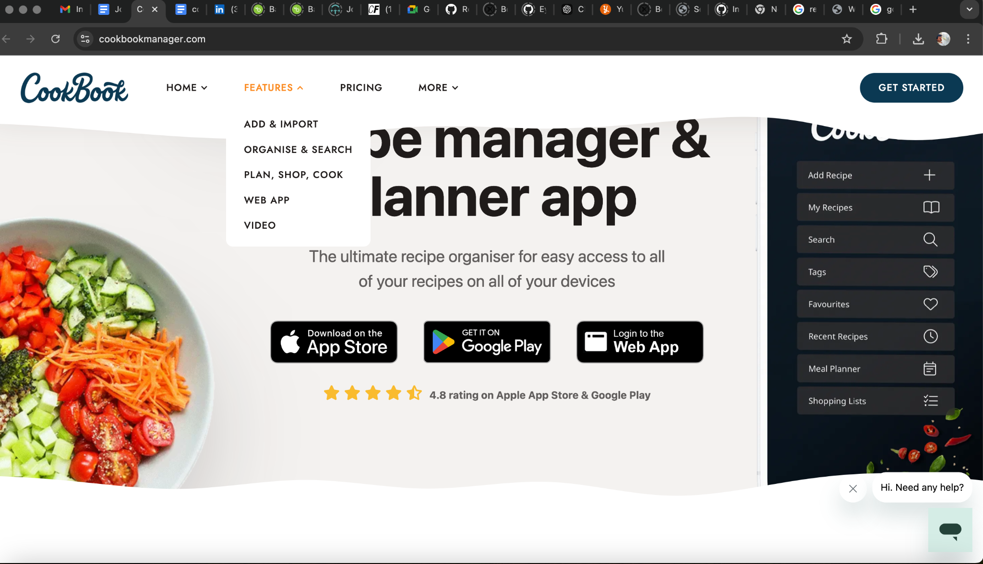

I love the clean and modern design of Cookbook Manager. The interface is simple and user-friendly, with a layout that makes it easy to navigate on both desktop and mobile devices. Recipes are well-organized into categories, and the search functionality is very effective, making it easy to find exactly what you need.

What really stands out to me is how personal and customizable the app feels. You can save, organize, and manage your own recipes, which makes it much more than just a recipe database. Each recipe page is beautifully designed with high-quality images and a clear, step-by-step format for the ingredients and instructions.

I also appreciate the tech-forward features like exporting recipes and managing lists. It feels like an app that’s designed to make cooking not only easier but also more enjoyable. It’s a perfect example of how design and functionality can come together to create an excellent user experience.

* [Yummly](https://www.yummly.com/):

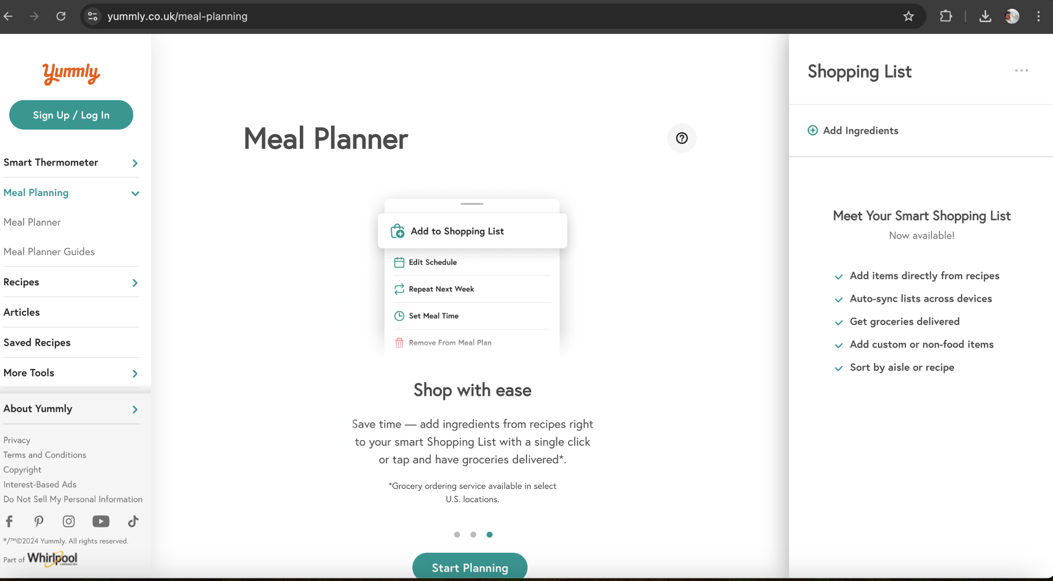

one of my favorite recipe apps because of its personalized and interactive design. The app tailors recipe suggestions based on your dietary preferences, allergies, and cooking style, making it feel like a personal assistant in the kitchen. The use of vibrant images and simple navigation makes exploring recipes fun and engaging.

I also love the detailed recipe pages on Yummly. Each one includes step-by-step instructions, nutritional information, and even estimated prep and cooking times. The "Smart Shopping List" feature is another standout—it streamlines grocery shopping by categorizing ingredients from selected recipes. Yummly is visually stunning and incredibly practical, making it a joy to use.

-[Tasty](https://tasty.co/):

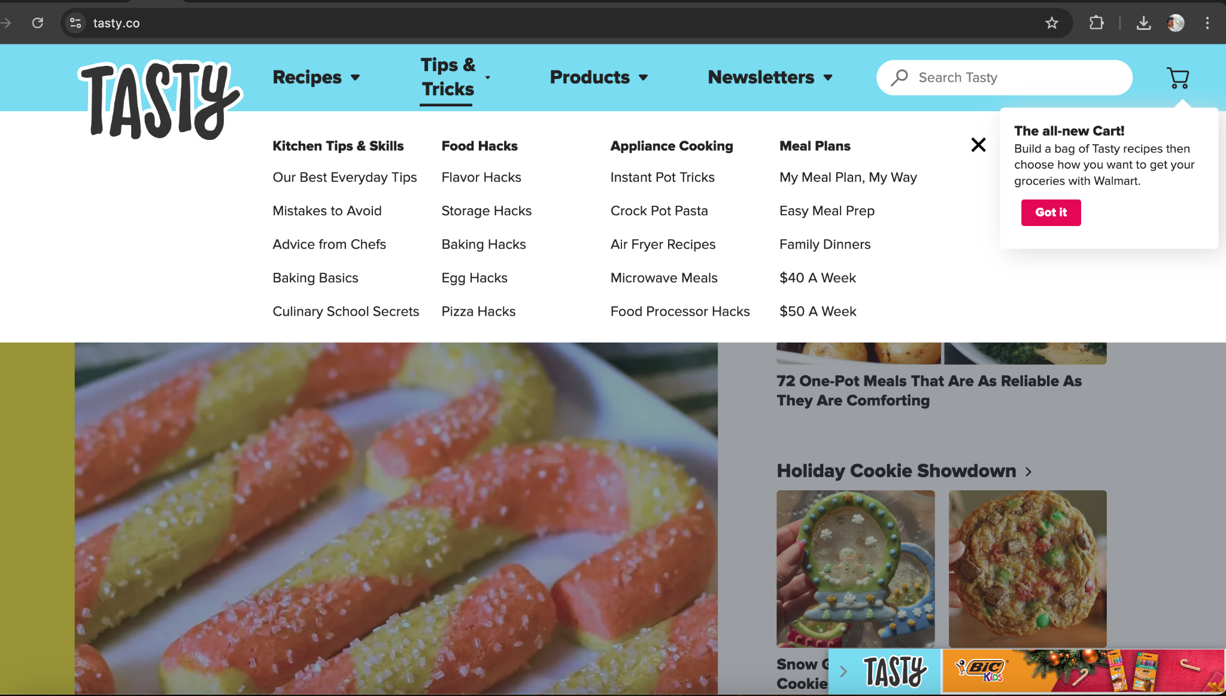

all about visual appeal and quick inspiration. The app’s bright, colorful design and short, captivating recipe videos make it perfect for anyone who enjoys learning visually. The layout is modern and intuitive, with filters to find recipes by ingredients, dietary preferences, and even mood!

One of the features I admire most about Tasty is its focus on accessibility. The videos are straightforward and show exactly how the dishes come together, making it easy for beginners to follow along. It also has a wide variety of recipes, from quick snacks to gourmet meals, and the ability to adjust serving sizes right within the app is super handy. Tasty makes cooking feel approachable and exciting.

My welcome page:

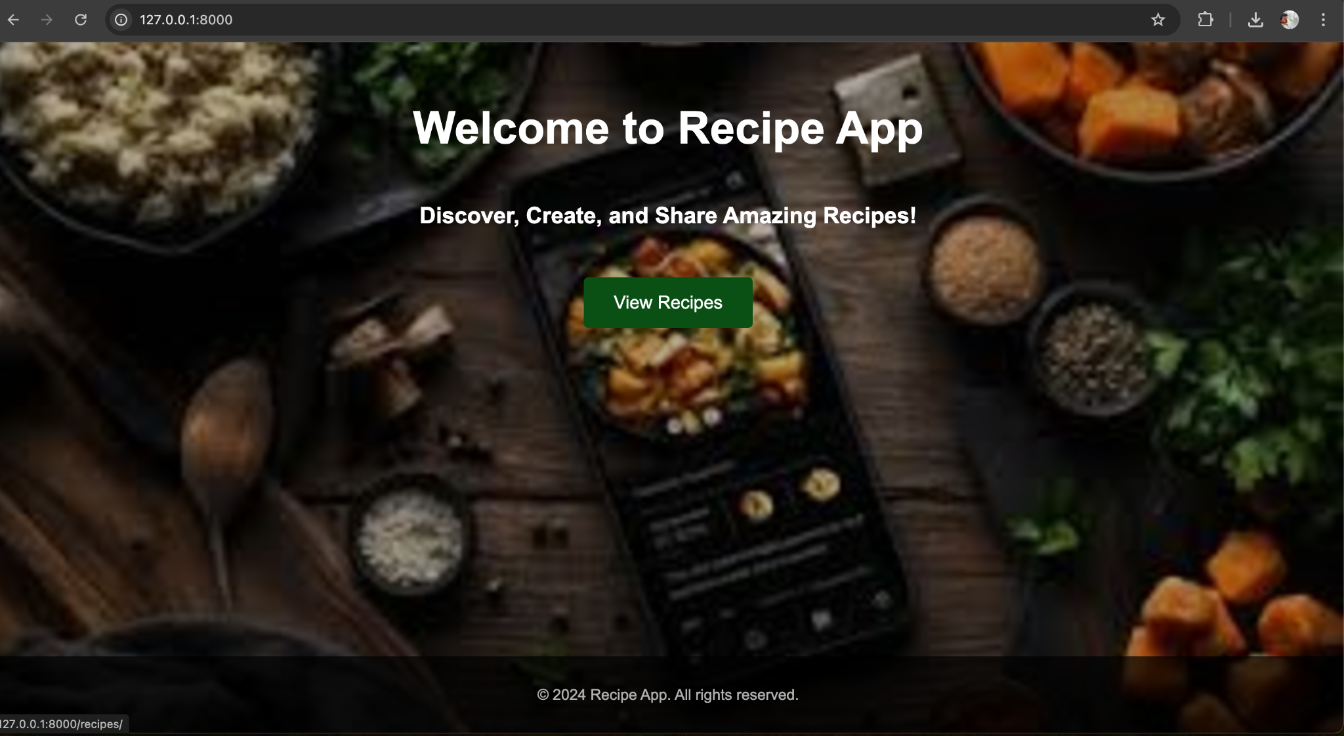

### **Reflection Questions**

#### **In your own words, explain Django static files and how Django handles them.**

Static files in Django are non-Python files like CSS, JavaScript, images, or fonts that are used to enhance the appearance and functionality of your application. Django provides a way to manage these files efficiently through the **STATICFILES_DIRS** and **STATIC_ROOT** settings. During development, Django's development server serves these static files automatically. However, in production, static files must be collected using the collectstatic command and served through a web server like Nginx. Static files are stored in a static folder and referenced using the {% static %} template tag in templates.

**-Look up the following two Django packages on Django’s official documentation and/or other trusted sources. Write a brief description of each**.

#### **ListView**

ListView is a Django class-based view that simplifies displaying a list of objects from the database. It automatically handles querying the model, passing the data to the template, and rendering the output. For instance, you can use ListView to show a list of recipes in your app without writing a lot of repetitive code.

#### **DetailView**

DetailView is a Django class-based view designed to show the details of a single object. It fetches the object from the database using a primary key, slug, or other identifier. It then passes the object to the specified template for rendering. For example, you could use DetailView to display all the details about a specific recipe, such as its ingredients, cooking time, and difficulty level.

**Exercise 2.6: User Authentication in Django**

### **Reflection Questions**

#### **1. Importance of Incorporating Authentication into an Application**

Authentication ensures that only authorized users can access certain parts of an application, protecting sensitive information and functionalities. For example, in a recipe-sharing app, authentication can restrict access to adding or editing recipes, ensuring that only logged-in users can modify content. Without authentication, anyone could potentially alter or delete data, compromising the integrity of the application and its user data.

#### **2. Steps to Create a Login for Your Django Web Application**

To create a login system in Django:

1. **Define Login URL in Settings:**
   * Add LOGIN_URL = '/login/' to your settings.py file.
2. **Create a Login View:**
   * Use Django’s built-in AuthenticationForm or a custom form to handle username and password inputs.
   * Use the authenticate() function to verify the user's credentials.
3. **Set Up URL Patterns:**
   * Define a URL pattern for the login view in urls.py.
4. **Protect Views:**
   * Use @login_required (for FBVs), i didn't use LoginRequiredMixin (for CBVs) to restrict access to specific views.
5. **Create Login Template:**
   * Design an HTML form for the login page that submits data via the POST method to the login view.
6. **Handle Redirection:**
   * Redirect users to a specific page (e.g., home or recipes list) upon successful login using redirect().
7. **Test the System:**
   * Attempt accessing protected views while logged in and logged out to ensure proper functionality.

**3. Django Functions  
  
- authenticate():Validates a user’s credentials (username and password). Returns a User object if successful, otherwise None.**

**-redirect():Redirects the user to a different URL (e.g., after login or logout). Accepts an absolute URL or a URL name.**

**-include():Includes other URL configurations into your main urls.py file, useful for organizing large applications**